**5CS372: Advanced Database System Lab.**

**Assignment No. 8**

Name: Divya Milind Kekade

PRN: 2020BTECS00038

----------------------------------------------------------------------------------------------------

**1. Do the installation and configuration of Oracle/MySQL/IBM DB2 distributed databases. [ Take minimum 3 nodes]**

**2. Use the above installed distributed database as backend for Assignment No.3 & 4.**

**3. Demonstrate the working by connecting portals to different nodes, adding data from one node and available / display on portal connected to another node etc.**

To create the cluster of MySQL servers, MySQL sandbox instances are used. Three different instances are created at different ports on localhost and they are added to single cluster. Only one cluster is primary node in the cluster which has the privileges of the read and write. Other nodes have only privileges of reading.

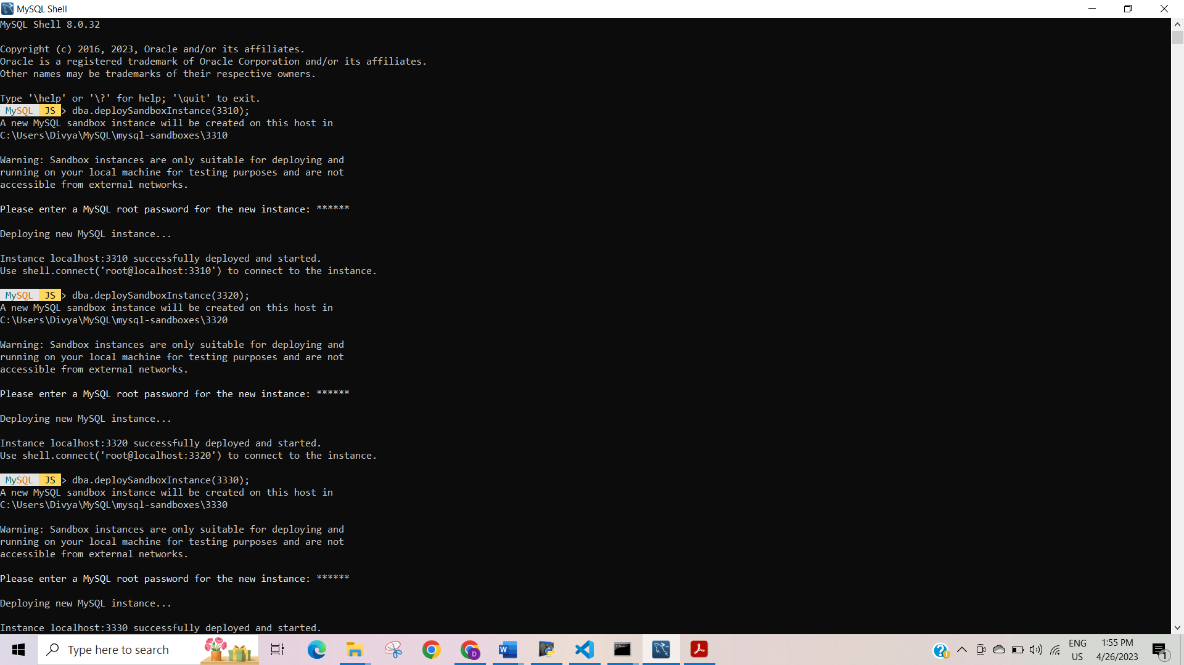

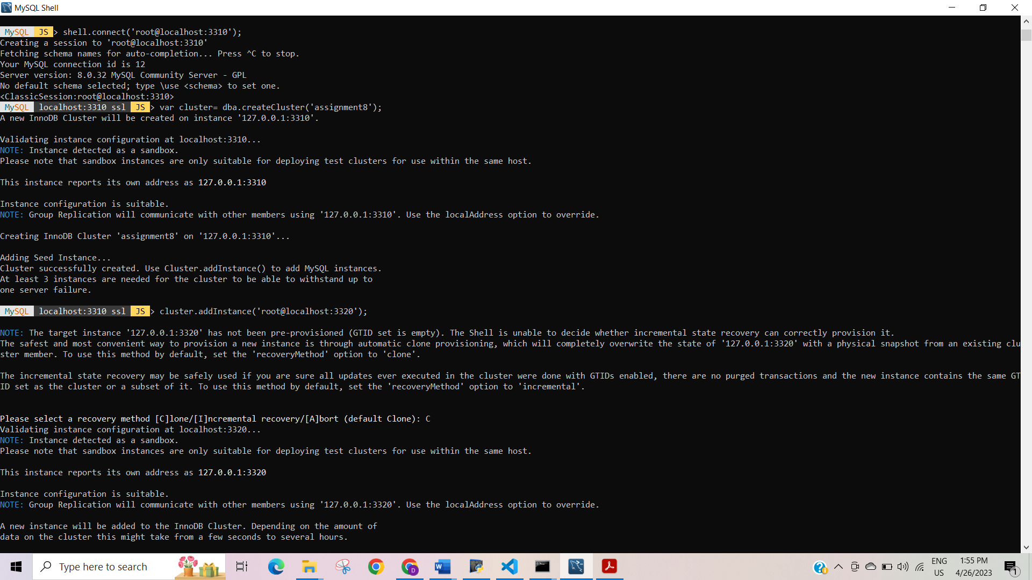

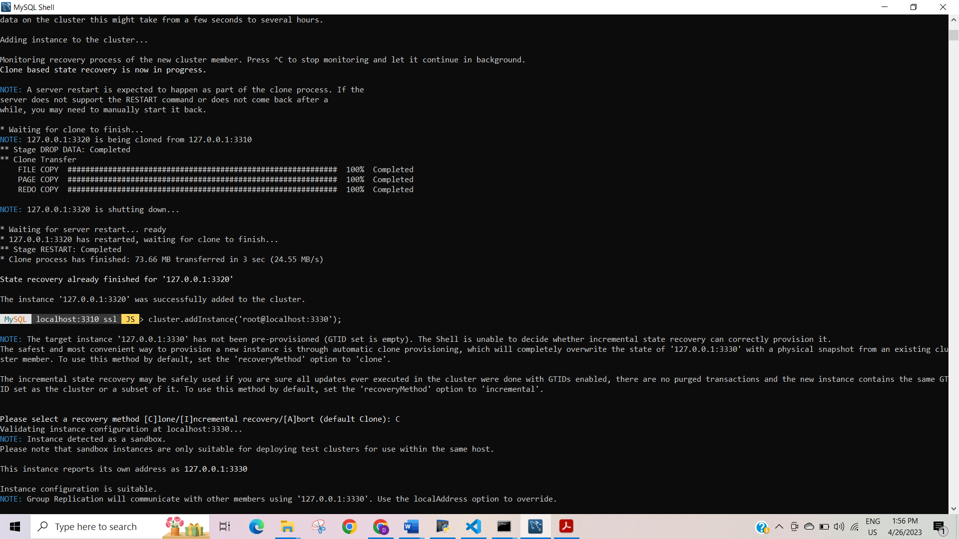

Cluster status:

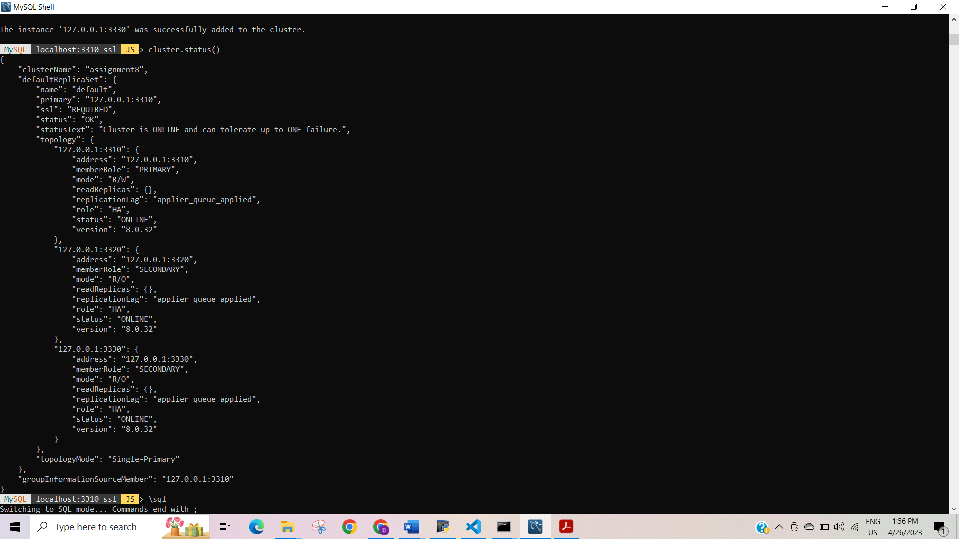

Newly created database get replicated to all other nodes in cluster:



